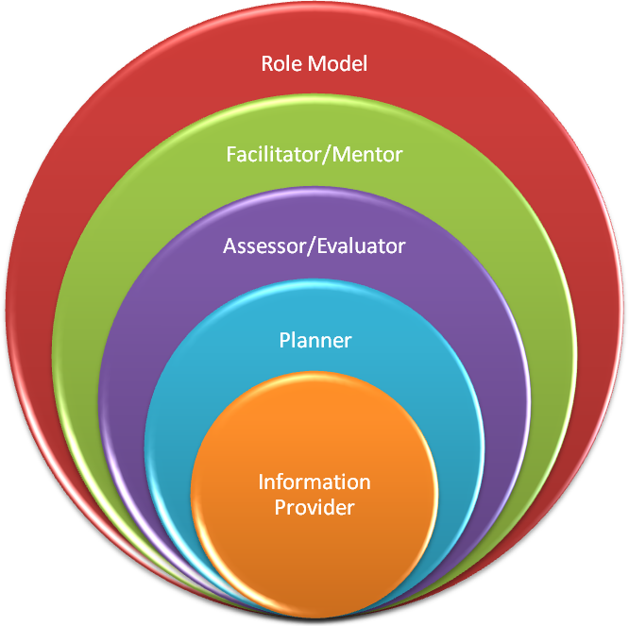 | Role Model  Perhaps the biggest role a trainer plays. Research shows trainees acquire many of the attributes of their trainer long after they’ve left a training scheme. Ways in which a trainer is the role model:  - On the job role model  - Teaching role model  Facilitator/Mentor  Clearly without this skill, there’s no point being a trainer! By facilitator we mean:  - Being a learning facilitator  - Being a mentor (including offering pastoral care)  Assessor/Evaluator  GP Trainers are of the trainee’s facilitator, mentor/friend and assessor (MRCGP assessments for instance; but there is also the informal assessment that goes on day to day at work: subconsciously gathering info from colleagues, reception staff, the nurses etc).  The trainer not only assesses the trainee but continuously evaluates the learning plan (or curriculum) to see whether it needs modifying or whether they’re “on track”.  Planner  By planner, I mean that the trainer is the person who often instigates the learning plan specific to the trainee allocated to him or her. In doing so, the trainer is a “course organiser” and “curriculum planner”. He or She may provide material for the trainee to help them ‘fit in’ and in doing so becomes a “study guide producer” or “resource material creator”  Information Provider  Finally, the trainer is a clinical/practical teacher (or lecturer) who gives clinical advice to the trainee and may provide topic based tutorials to further enhance learning.

